Auth0 Sign-up and Application Registration

Sing up: <https://auth0.com/signup?ocid=7014z000001cbvZAAQ-aPA4z0000008OZeGAM>

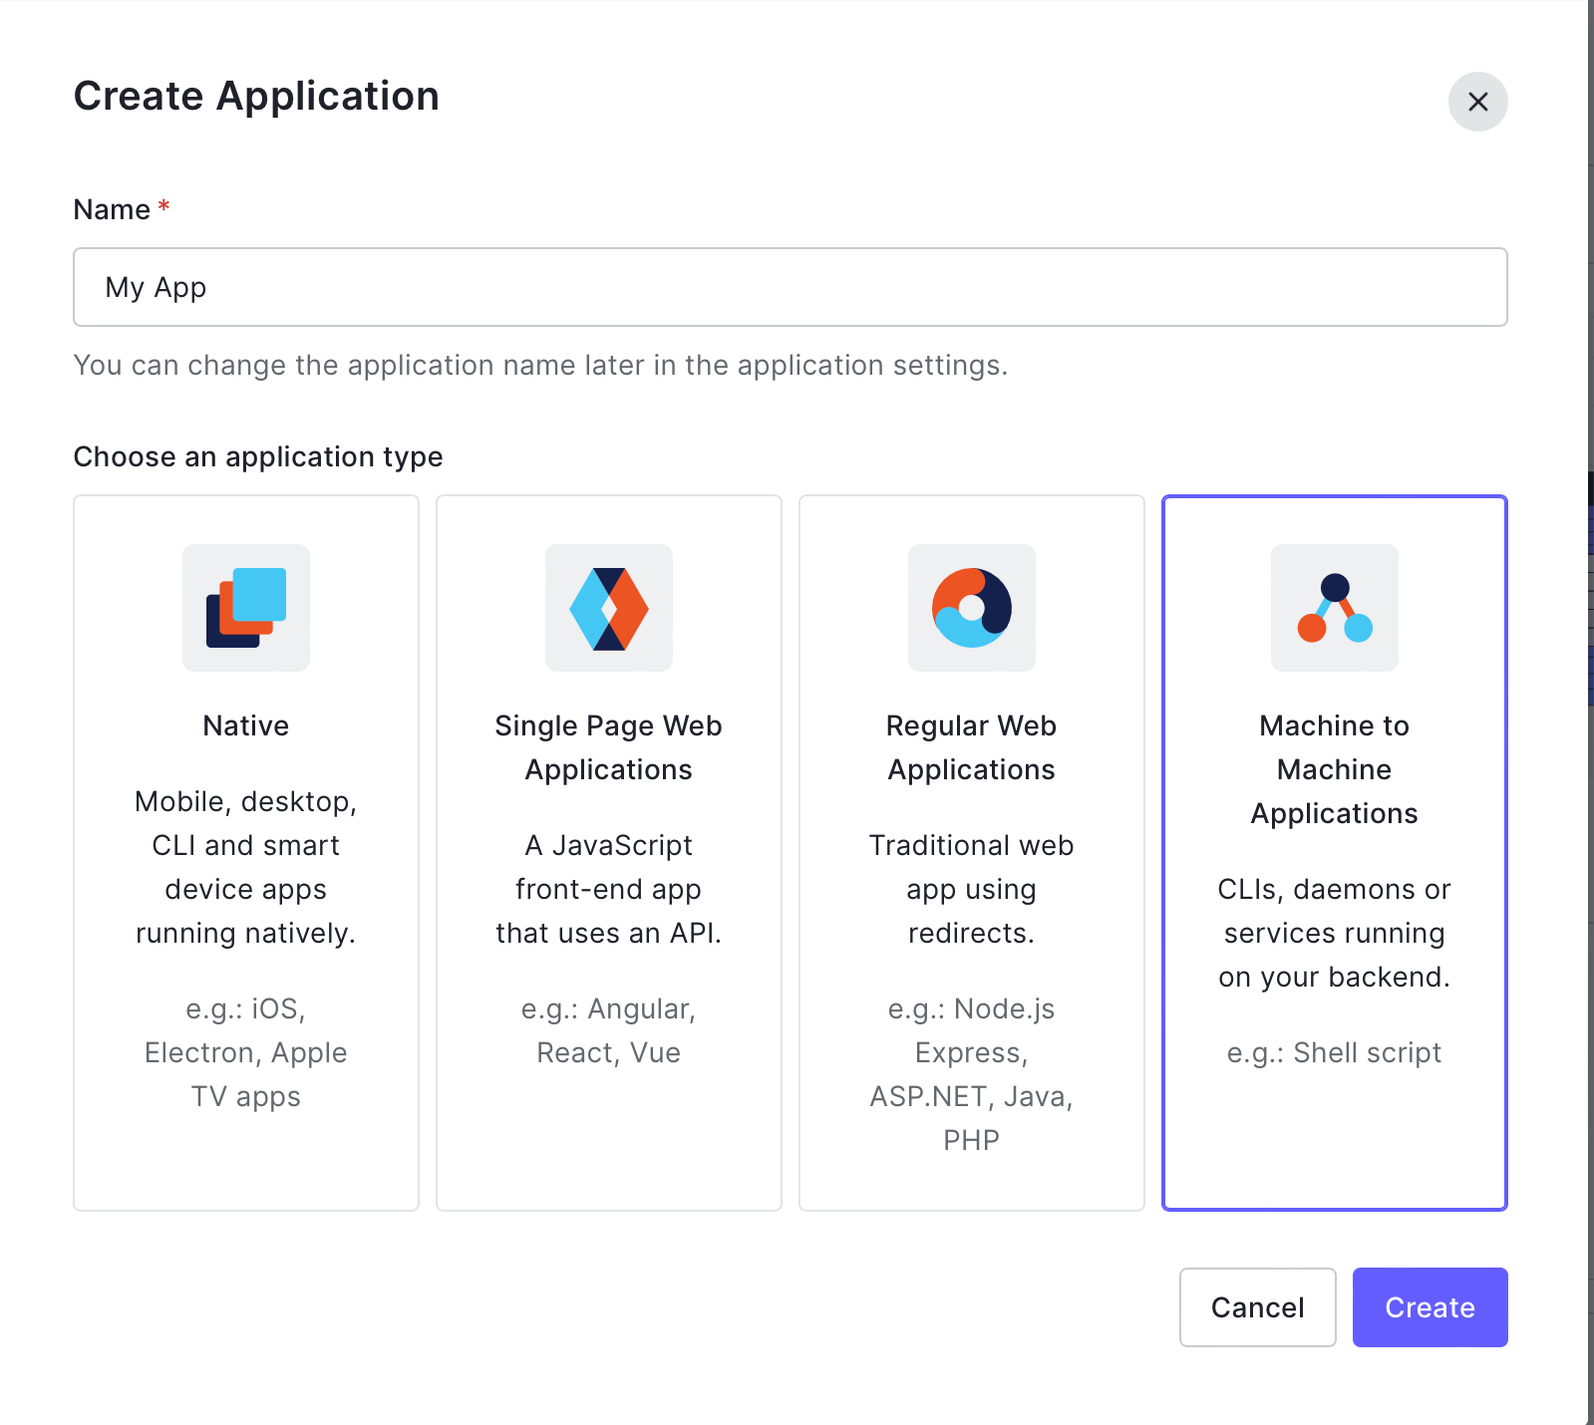

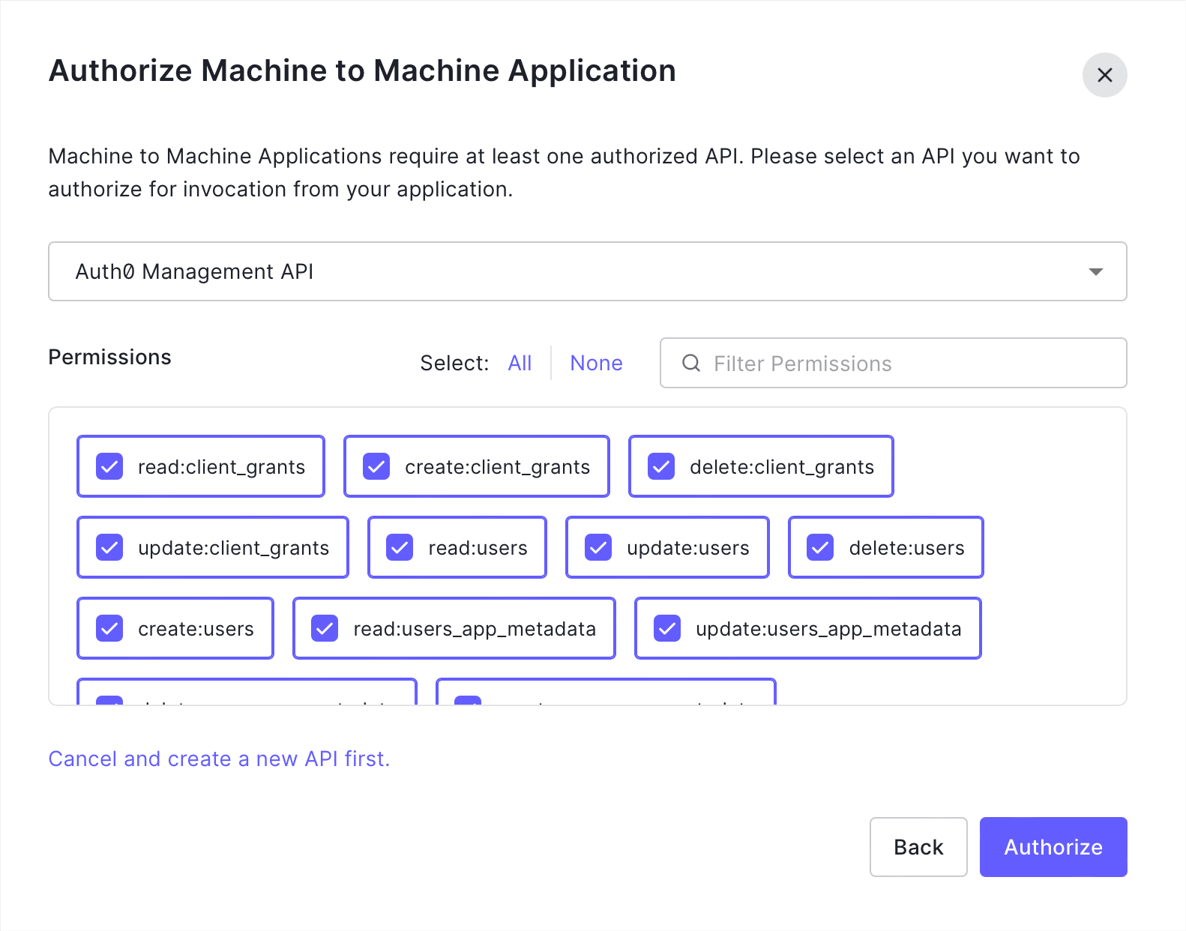

Use the details in the cURL sample to create a postman request and get the token.

curl --request POST \

--url https://<domain>.auth0.com/oauth/token \

--header 'content-type: application/json' \

--data '{"client_id":"","client_secret":"","audience":"https://<domain>.auth0.com/api/v2/","grant_type":"client_credentials"}'

Send the token as Bearer token to Microservice API.